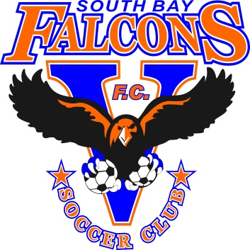

Rules for Coaches and Parents of South Bay Falcons FC

Training payment is due on the first week of month on Tuesday thru Friday only at the office. If payment is not received by the first week a late fee will be included with the payment.

Coaches have to obey the rules, the time of practice and the space giving to them for practice. All fields must be treated with respect even our own fields we play and practice on. All players must wear the correct practice gear (White or black falcons shirt, black shorts and black socks). All players not in this gear are not allowed to practice. All registrations for club are opened on the month of January and have to be done paid by April. First club payment of $1000 must be submitted by January. If any team decides to leave they will not be given a refund for the club payment. All registrations for club are opened on the month of January and have to be done paid by April.

Looking forward to seeing you’ll next season

Thank You South Bay Falcons FC